WHAT: Art III - Honors and Standards: Summer Photography Assignment

WHEN: Due Friday, August 25th

HOW:
- Use a digital camera or your phone
- Deal breaker # 1: COMPOSITION: how an artist fills the space. Be the art director and decide what makes it into the shot. Don’t rely on cropping afterwards.
- Deal breaker # 2: LIGTHING: If it is too dark, the viewer can’t see the subject. If it is overly lit, the details are washed out. Try a variety of light sources: natural sunlight, spotlights, etc (flashes are rarely great)
- Deal breaker # 3: Do not include shots taken by other people or found on the internet.
- Suggestion # 1: Find an interesting angle, zoom in, zoom out, stand below or above eye level
- Suggestion # 2: stuck for ideas > make a list > ideas beget ideas > look up the definition of the word for clarity > pictures provided are for inspiration only and in no way limit your subject matter
- These pictures will be used as reference photos for this year’s artwork. Bad pictures make for bad artwork.
- The photos will count for two homework grades.
- Bring photos in on a flash drive. Please do not email them.
- Read directions carefully

Assignment #1: SHINY: 3 photos > each of different object(s) > at least one is in color, one is black and white, third is your choice
Assignment #2: WOVEN TEXTURE: 3 photos > each of a different object(s) > One black and white and one in color
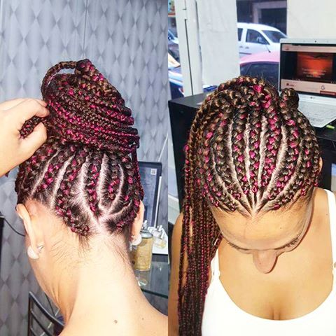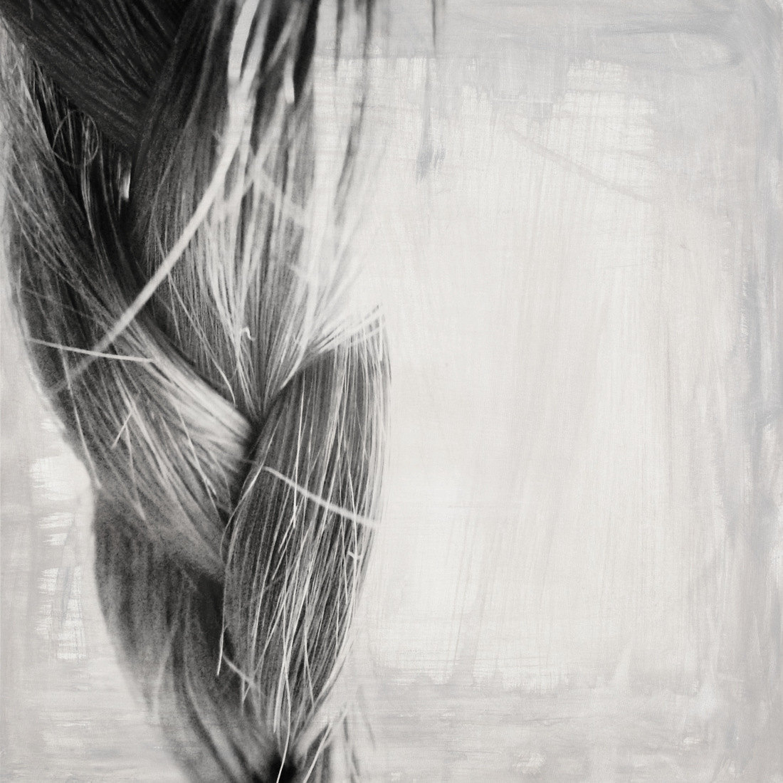
Assignment #3: SHADOWS: 3 photos > each a different object(s) > All black and white > You can capture shadows you see or be the art director and create your own with spotlights.
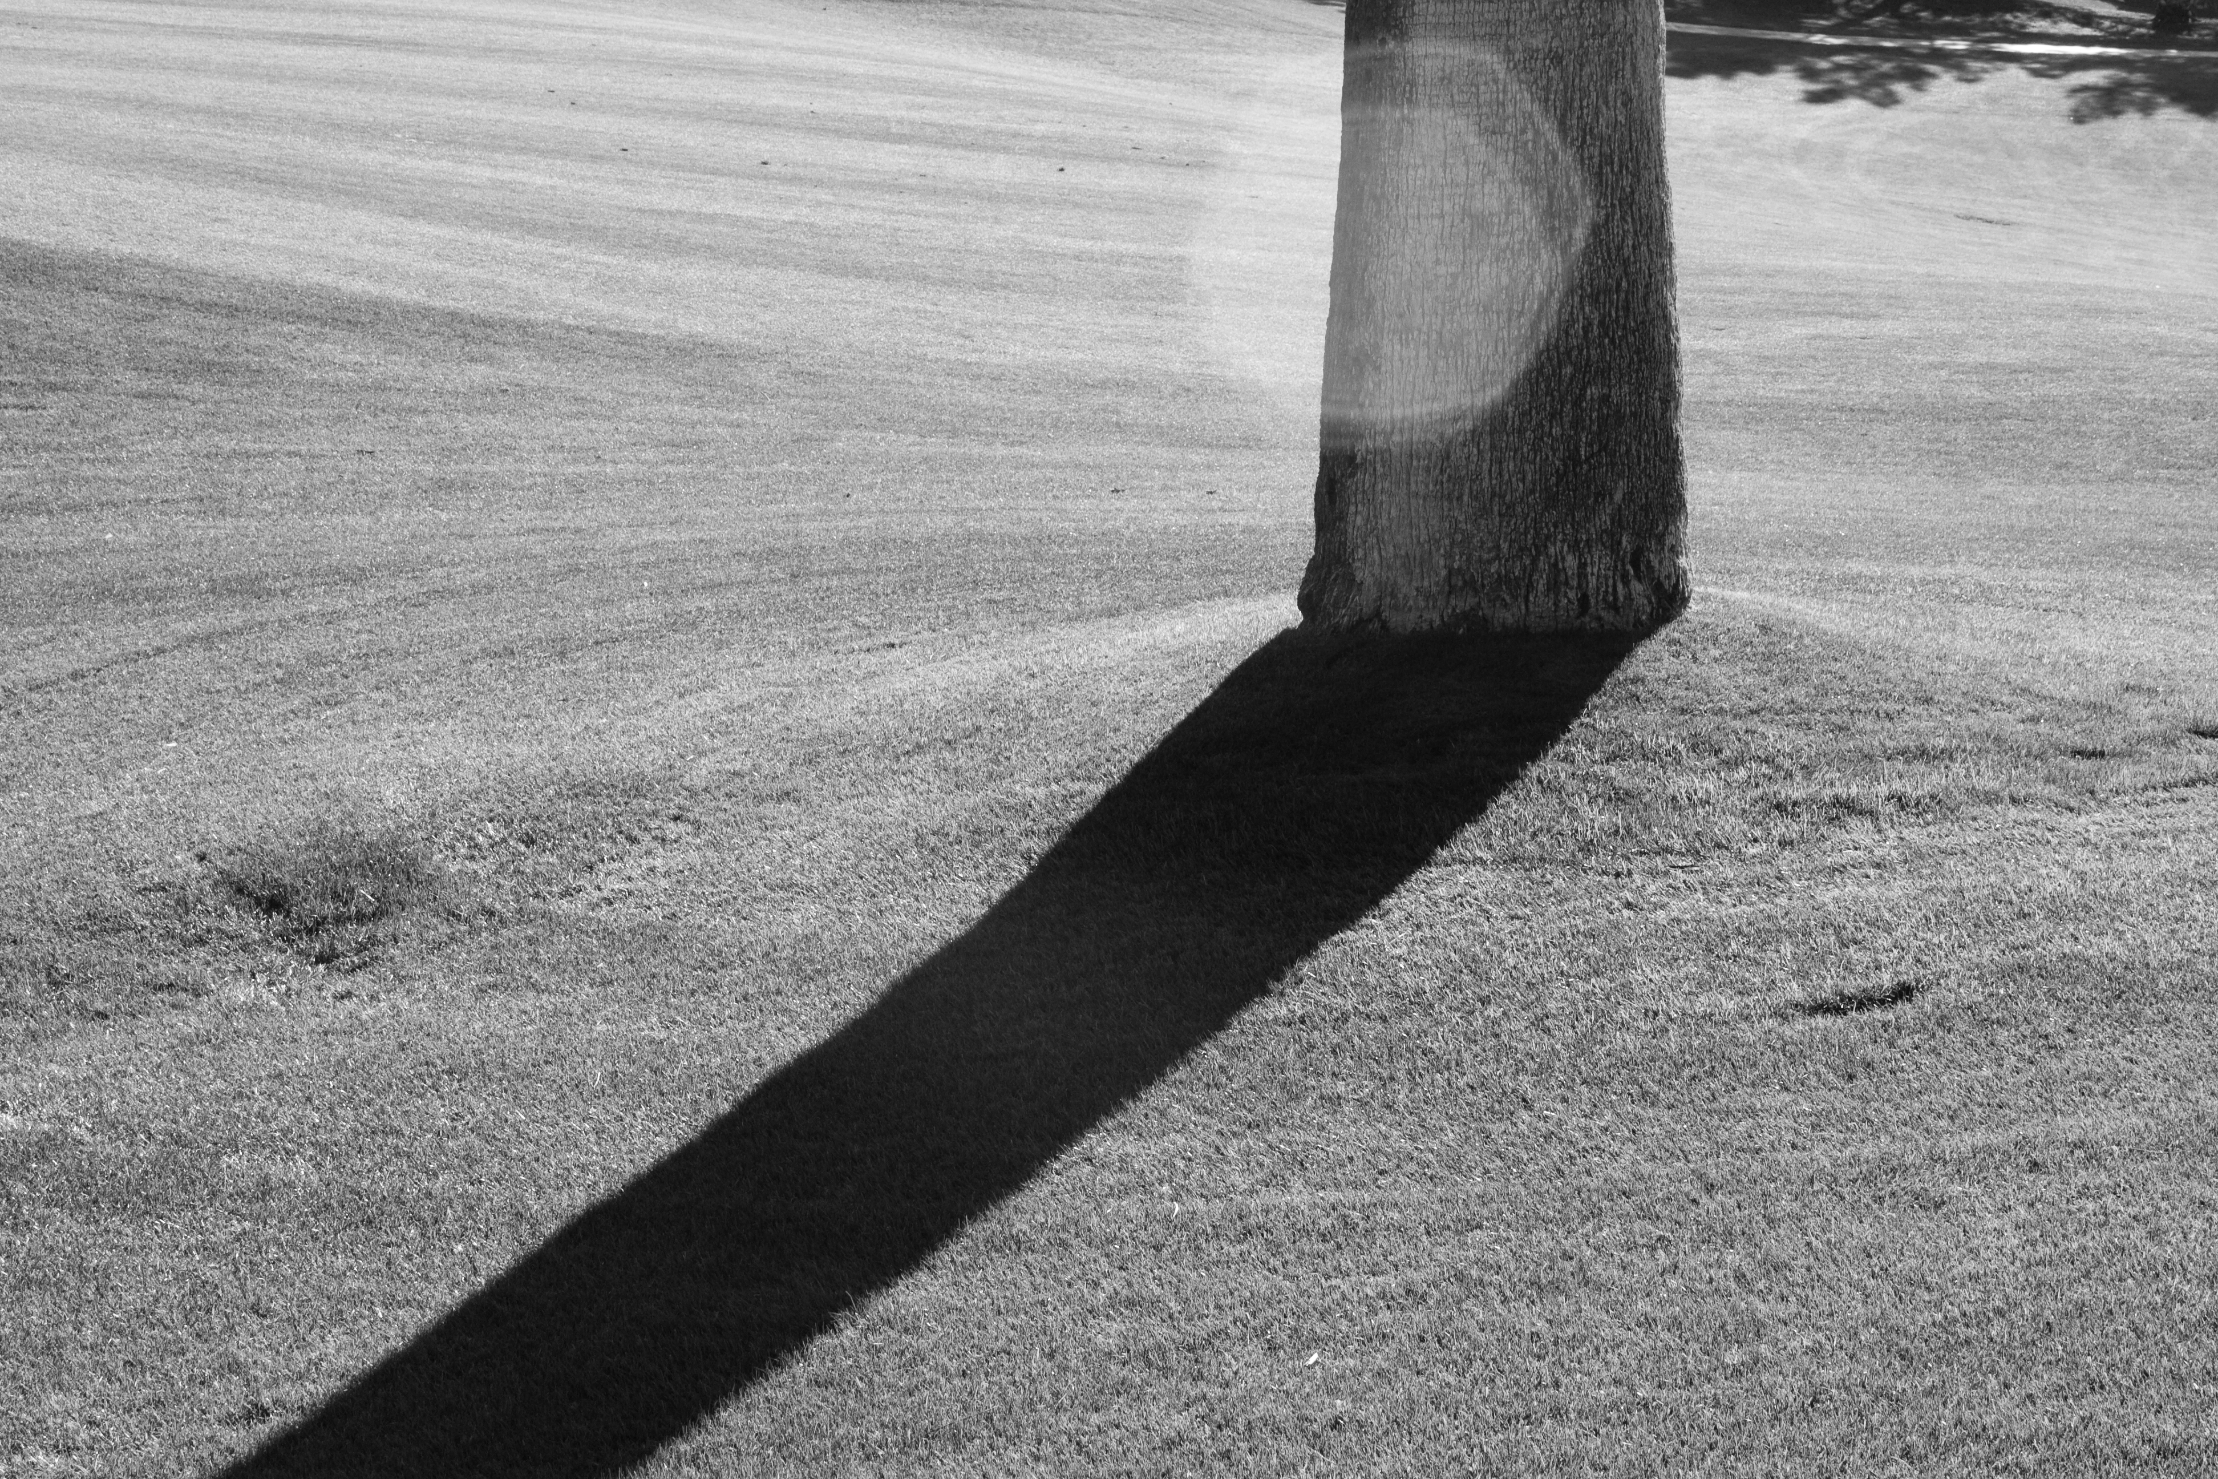
THIS IS BORING
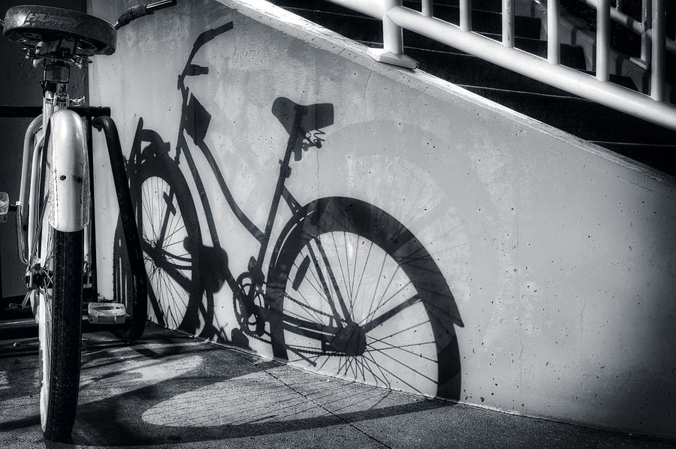
THESE ARE BETTER
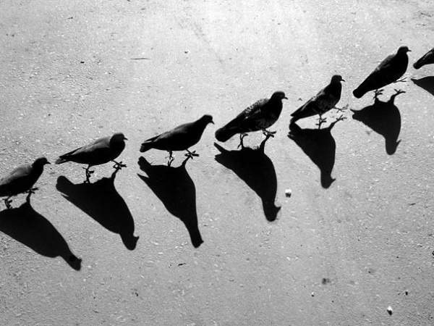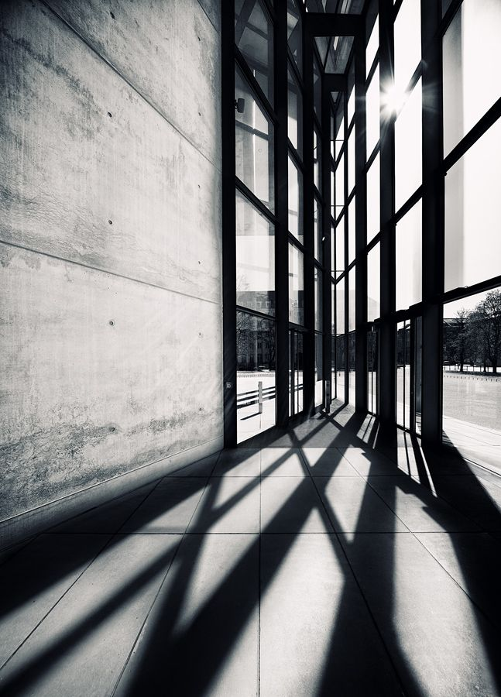

Assignment #3: ORGANIC: 3 photos > each a different object(s) > Your choice regarding black and white or color

